Safaan Hashmi

Lecture 2 27-July-2024 Sat

Practice Problems

**1. Print sum of digits of a positive number**

import java.util.*;

class SumofDigits {

public static void main(String[] args) {

long n,m, sumOfDigits;

Scanner sc = new Scanner(System.in);

n = sc.nextInt();

m=n;

for(sumOfDigits = 0 ; n!=0 ; n/=10) {

sumOfDigits += n%10;

}

System.out.println("Sum of the Digits of "+m+" is = "+sumOfDigits);

}

}

OUTPUT -:

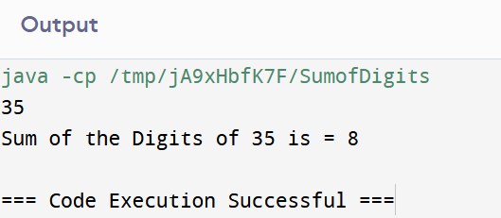

**2. WAP to check whether a given number is palindrome**

import java.util.*;

class Palindrome {

public static void main(String[] args) {

Scanner sc = new Scanner(System.in);

int n = sc.nextInt();

int r,sum=0,temp;

temp=n;

while(n>0){

r=n%10;

sum=(sum*10)+r;

n=n/10;

}

if(temp==sum)

System.out.println("palindrome number ");

else

System.out.println("not palindrome");

}

}

OUTPUT -:

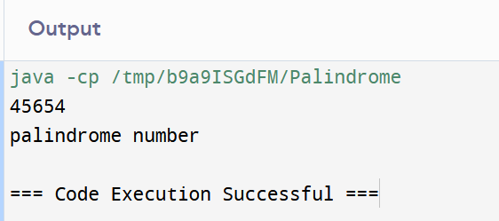

**3. Fibonacci series using a function**

import java.util.*;

public class fibonacci{

static void Fibonacci(int N)

{

int num1 = 0, num2 = 1;

for (int i = 0; i < N; i++) {

System.out.print(num1 + " ");

int num3 = num2 + num1;

num1 = num2;

num2 = num3;

}

}

public static void main(String args[])

{

// Given Number N

Scanner sc = new Scanner(System.in);

int N = sc.nextInt();

Fibonacci(N);

}

}

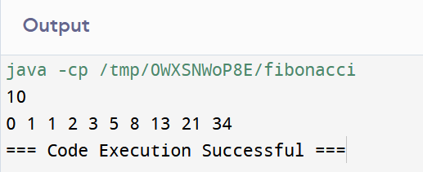

**4. WAP to generate all the prime numbers between 1 and n where n is a value**

import java.util.*;

class gfg {

static void prime_N(int N)

{

int x, y, flg;

System.out.println(

"All the Prime numbers within 1 and " + N

+ " are:");

for (x = 1; x <= N; x++) {

if (x == 1 || x == 0)

continue;

flg = 1;

for (y = 2; y <= x / 2; ++y) {

if (x % y == 0) {

flg = 0;

break;

}

}

if (flg == 1)

System.out.print(x + " ");

}

}

public static void main(String[] args)

{

Scanner sc = new Scanner(System.in);

int N = sc.nextInt();

prime_N(N);

}

}

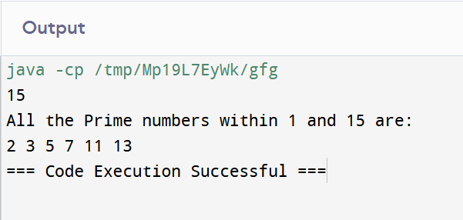

**5. Wap to sort an integer array using bubble sort**

class BubbleSort {

void bubbleSort(int arr[])

{

int n = arr.length;

for (int i = 0; i < n - 1; i++)

for (int j = 0; j < n - i - 1; j++)

if (arr[j] > arr[j + 1]) {

// swap temp and arr[i]

int temp = arr[j];

arr[j] = arr[j + 1];

arr[j + 1] = temp;

}

}

void printArray(int arr[])

{

int n = arr.length;

for (int i = 0; i < n; ++i)

System.out.print(arr[i] + " ");

System.out.println();

}

public static void main(String args[])

{

BubbleSort ob = new BubbleSort();

int arr[] = { 64, 34, 25, 12, 22, 11, 90 };

ob.bubbleSort(arr);

System.out.println("Sorted array");

ob.printArray(arr);

}

}

